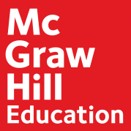
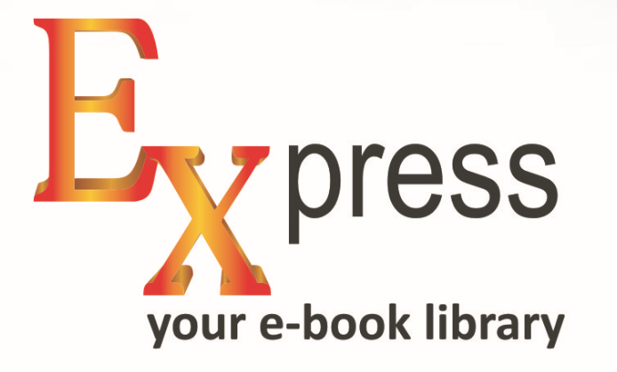

Your digital library with McGraw Hill Education’s world famous textbooks & references

How to access Express Library?

The Library can be accessed via IP range authentication wherein the user doesn’t require login credentials to access the content if connected through Institute IP or Individual based access wherein the individual users may use their respective user id and password to access the e-book library

Below are the steps to access e-book:

- Visit the URL - http://mcgrawhilleducation.pdn.ipublishcentral.com/
- Click on Bookshelf to access titles/E-books subscribed by your Institute
- Search titles/books as required
- To read E-Book Online – Click on Online Reading Options
- To download E-book - Click on Download Option and follow the instructions as mentioned

